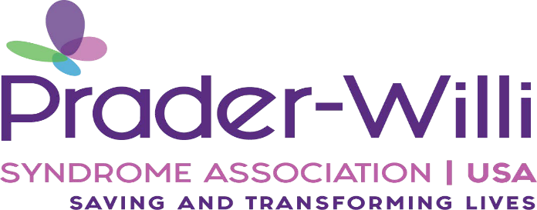

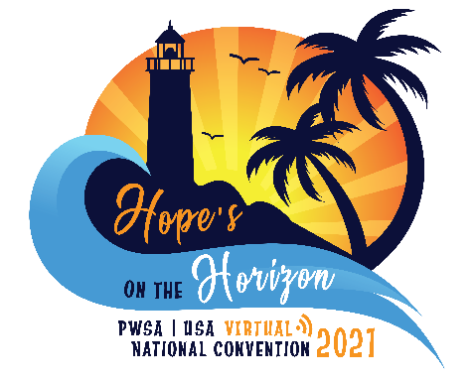
Prader-Willi Syndrome Association | USA
36th MEDICAL & SCIENTIFIC CONFERENCE

Wednesday & Thursday, June 23rd - 24th, 2021

11am-5:15pm EST

VIRTUAL EVENT
Submit Your Abstract by 6:00 P.M. on Friday, April 2nd, 2021

PWSA | USA Abstract Submission Instructions

PWSA | USA cordially invites abstract submissions for a presentation of recent research or related scientific or medical topics on the subject of Prader-Willi syndrome for our 36th Annual Medical & Scientific Conference. To participate in the medical and scientific program, submit a 1-page abstract on a relevant topic to the Medical & Scientific Conference Committee for review by April 2nd, 2021. Abstract submissions should be 1 page in length, single spaced with a 1-inch margin and minimum 12 pt. font. Author and title information should follow the sample format given below. Abstracts should be sent by e-mail to our Conference Co-Chairs Ann Manzardo, Ph.D., at amanzardo@kumc.edu with a copy to James Loker, M.D., at LOKERJ@bronsonhg.org.

This activity has been planned and implemented in accordance with the accreditation requirements and policies of the Accreditation Council for Continuing Medical Education (ACCME) through the joint providership of Western Michigan University Homer Stryker M.D. School of Medicine and Prader-Willi Syndrome Association | USA. Western Michigan University Homer Stryker M.D. School of Medicine is accredited by the ACCME to provide continuing medical education for physicians.

Western Michigan University Homer Stryker M.D. School of Medicine designates this live activity for a maximum of 10 AMA PRA Category 1 Credits™. Physicians should claim only the credit commensurate with the extent of their participation in the activity.

We look forward to your participation in an exciting Medical & Scientific program.

For information and updates about the PWSA | USA Convention please visit
https://www.pwsausa.org/get-involved/join-now/attend-convention/

View Sample Abstract Below:
Survival Trends in Prader-Willi Syndrome in Relationship to Cause of Death and Historical Timeframe
Ann M. Manzardo¹; James Loker²; Janalee Heinemann³; Carolyn Loker³; Merlin G. Butler¹
¹Departments of Psychiatry & Behavioral Sciences and Pediatrics, University of Kansas Medical Center, Kansas City, Kansas, USA; ²Bronson Children’s Hospital, Kalamazoo, Michigan USA; ³Prader-Willi Syndrome Association (USA), Sarasota, Florida, USA
Introduction/Background: Prader-Willi syndrome (PWS) is a complex genetic disorder characterized by hyperphagia and morbid obesity with increased cardiopulmonary and hyperphagia-related mortality. Detailed genetic characterization of PWS has enabled diagnosis in infancy increasing the opportunity for treatments (e.g., growth hormone) and intervention to control access to food and prevent the onset of obesity. Survival trends in PWS were evaluated to assess life course and impact of modern interventions on mortality risks and cause of death.
Methods: PWSA (USA) mortality syndrome-specific database of death reports was developed through a cursory bereavement program for PWSA(USA) families using a brief survey created in 1999. Survival trends and causes of death were statistically examined for 425 deaths (224 males, 199 females, 6 unknown) with a known age of death between 1973 and 2015 using Cox Proportional Hazards regression modeling, a method used to investigate the influence of different factors upon the time to an event such as the age of death. The relative risk of death for a condition is presented as a “hazard ratio.” Gender, cause of death and cohort effects for recent deaths (years 2000-2015, N=331) relative to deaths prior to 2000 (N=94) were examined to generate log rank statistics and Kaplan-Meier curves.
Results/Discussion: Median overall survival in PWS was 29 years of age [95%CI (27-32yrs)] achieving 99% mortality by 60 years of age. Overall risk or “Hazzard” of death due to respiratory failure was significantly increased over all-causes [Log-Rank χ² = 8.2, df=1; p<0.004; Hazard Ratio (HR)=1.4; 95%CI= 1.1-1.8] which was attributable to a sex specific increase in females. Males showed a significantly increased risk of early mortality over females [χ2=5.0, p<0.025; hazard ratio=1.2 (95%CI 1.0, 1.5)] with a significantly increased risk of presumed hyperphagia-related causes (accidents, choking, GI-problems). The maternal disomy 15 subtype also showed a significantly increased risk [HR=2.0 (95%CI 1.0 to 3.9); χ2 =4.1, p<0.04] of death due to cardiopulmonary vs hyperphagic causes than the 15q11-q13 deletion. When considering cohort effects, risk for all-cause mortality in PWS was 1.5 (95%CI=1.2-1.9) times higher for the Early than the Recent era cohort seen in female cardiac failure (HR=1.8; 95%CI=1.3-2.6), pulmonary embolism (HR=6.1; 95%CI=1.7-22), and GI-related (HR=3.2; 95%CI=1.1-7.4) causes.
Conclusions: We identified gender and subtype-specific risks for early mortality in PWS with a significantly younger age of death found for males. Females showed an increased risk of obesity-related, cardiopulmonary problems while males were more prone to hyperphagia-related activities/accidents. Maternal disomy 15 subtype may increase risk of cardiopulmonary death relative to deletion subtype, but confirmatory studies are needed. Earlier diagnosis improved medical management and proactive interventions to prevent morbid obesity in recent cohorts have significantly reduced cardiovascular and GI-related deaths among females with PWS; however, lower weight and increased mobility may have increased the risk of accidental death among males. More research is needed to address underlying vulnerability to respiratory failure.

Prader-Willi Syndrome Association | USA

For over 40 years, PWSA |USA has been the only national support agency for people living with PWS, their families and the professionals who serve them. PWSA |USA’s mission includes providing support to families, creating educational materials, funding research and encouraging collaboration among researchers, clinicians and families. PWSA |USA has established Scientific and Clinical Advisory Boards consisting of key professionals, physicians and scientific investigators, many as pioneers in the field, to address medical care, research, investigations, etc. in this syndrome.

The registration fee is $150 for the Medical & Scientific Conference to be held on Wednesday & Thursday, June 23rd – 24th.

Following the Medical & Scientific Conference

In addition, please consider registering for the General Conference on June 25th & 26th directly following the Medical & Scientific Conference as our guests for no additional fees.

The theme of this year’s National Convention is “Hope’s on the Horizon”.

At the General Conference, experts will present on a large variety of important topics related to PWS with interaction encouraged not only by professionals, but also by the hundreds of parents, professionals, caregivers and others attending the meeting.

